Courtyard at Old Town  802 East 2nd Street North  Wichita, Kansas  For reservations call:  316 264 5300  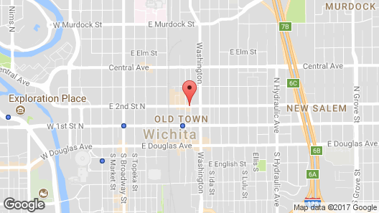  Room Rate: $107.00 + Applicable Taxes  Reservations should be made prior to September 1, 2017 to receive seminar rate. Please ask for the Tri-State Polygraph Seminar rate when making your reservations.  (Highway 400/Highway 54, exit north onto Washington Street, go to 2nd Street and make a left (west). Arrive at destination.) |  |  |  |  | Rebecka Schoenecker-Stich  Secretary/Treasurer  Kansas Polygraph Association  P.O. Box 1244  Parsons, KS 67357 |  |  | Tri-State Polygraph Seminar  Hosted by  Kansas Polygraph Association  September 27-29, 2017  Courtyard Wichita at Old Town  802 East 2nd Street North  Wichita, Kansas  - Kansas Polygraph Association  P.O. Box 1244  Parsons, Kansas 67357  Phone: 620 421-6550, Ext. 1601  Fax: 620 421-8784  E-mail: Rebecka.Schoeneckerstich@ks.gov

Registration Form  Tri-State Polygraph Seminar  September 27-29, 2017  Courtyard at Old Town  Wichita, Kansas  316 264 5300  Name: ____________________________________  Agency: ___________________________________  Address: __________________________________  City/State/Zip: _____________________________  E-mail: ___________________________________  Name as you want it on your certificate:  _________________________________________Seminar Cost:  NAPE, MPA, and KPA members: $150.00  NAPE, MPA, and KPA members after September 11, 2017: $175.00  Non-members: $175.00  Please make checks payable to KPA or we now can accept credit card payments.  Send registration and payment to:  Rebecka Schoenecker-Stich  Secretary/Treasurer  Kansas Polygraph Association  P.O. Box 1244  Parsons, KS 67357  E-mail: Rebecka.Schoeneckerstich@ks.gov  Phone: 620 421 6550, Ext. #1601  FAX: 620 421 8784 |  |  | KPA CONTACT INFORMATION  President: James Bridges  Vice President: Kelly R. Davis  Secretary/Treasurer: Rebecka Schoenecker-Stich  Chairman, Board of Directors: Dave Brede  Board of Directors: Michael Mann  Ralph Sorrell  John Harrison  For more information contact:  Rebecka.Schoeneckerstich@ks.gov  Please contact Robert Riggs at 816 444 6886 or Robert.Riggs@ameriguard.org if you are interested in the golf outing on Wednesday morning, September 27th. |  |  | Seminar Schedule  Wednesday, September 27  11:00 a.m. – 12:45 p.m. Registration  12:45 p.m. – 1:00 p.m. Opening Ceremony  1:00 p.m. – 5:00 p.m. Question  Formulation  And Chart Scoring  Thursday, September 28  8:00 a.m. – 5:00 p.m. Rapport – “The  Nice Examiner”  Cognitive Interviewing  Cognitive Veracity  Assessment  Friday, September 29  8:00 a.m. – 12:00 p.m. Interrogation and the  Future  Presenter is Neil Barker, retired polygraph examiner for the Royal Canadian Mounted Police.

