Embassy Suites by Hilton  10401 S. Ridgeview Road  Olathe, Kansas  For reservations:  Call: 913 353 9280 or online  www.kansascityolathe.embassysuites.com  3-letter code (KBI)  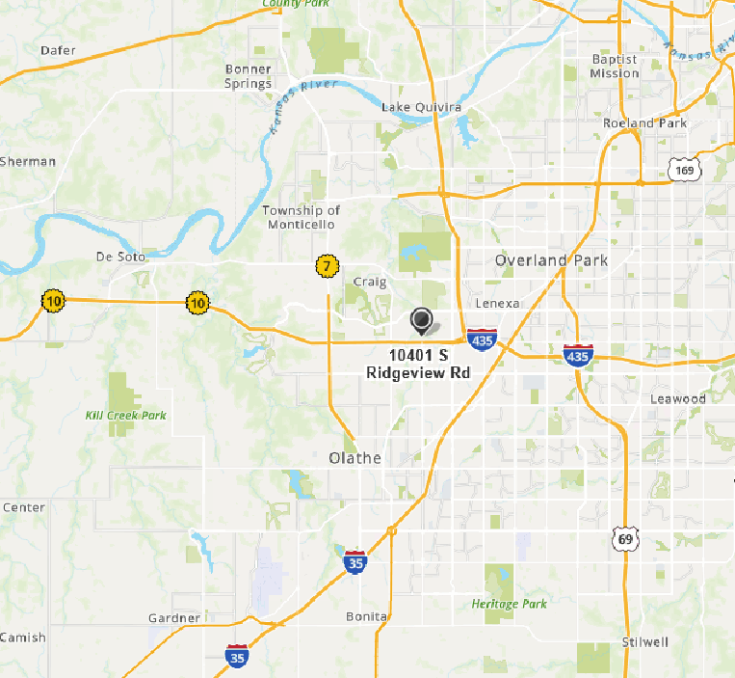  Room Rate: $120.00 + Applicable Taxes  Reservations should be made prior to September 26, 2021 to receive seminar rate. Please ask for the Tri-State Polygraph Seminar rate when making your reservations. |  |  |  |  | Rebecka Schoenecker-Stich  Secretary/Treasurer  Kansas Polygraph Association  P.O. Box 1244  Parsons, KS 67357 |  |  | Tri-State Polygraph Seminar  Hosted by  Kansas Polygraph Association  October 20 – 22, 2021  Embassy Suites by Hilton  10401 S. Ridgeview Road  Olathe, Kansas  - Kansas Polygraph Association  P.O. Box 1244  Parsons, Kansas 67357  Phone: 620 421-6550, Ext. 1601  E-mail: Rebecka.Schoeneckerstich@ks.gov

Registration Form  Tri-State Polygraph Seminar  October 20 – 22, 2021  Embassy Suites by Hilton  Olathe, Kansas  913 353 9280  Name: ____________________________________  Agency: ___________________________________  Address: __________________________________  City/State/Zip: _____________________________  E-mail: ___________________________________  Name as you want it on your certificate:  _________________________________________Seminar Cost:  NAPE, MPA, and KPA members: $150.00  NAPE, MPA, and KPA members after  September 26, 2021 $175.00  Non-members: $175.00  Please make checks payable to KPA or we now can accept credit card payments via Square.  Send registration and payment to:  Rebecka Schoenecker-Stich  Secretary/Treasurer  Kansas Polygraph Association  P.O. Box 1244  Parsons, KS 67357  E-mail: Rebecka.Schoeneckerstich@ks.gov  Phone: 620 421 6550, Ext. #1601 |  |  | KPA CONTACT INFORMATION  President: Bruce Powers  Vice President: John Harrison  Secretary/Treasurer: Rebecka Schoenecker-Stich  Chairman, Board of Directors: Kelly Davis  Board of Directors: Rick Lees  R. Mark Cantrell  Keith Thomas |  |  | Seminar Schedule  Wednesday, October 20, 2021  11:00 a.m. – 12:45 p.m. Registration  12:45 p.m. – 1:00 p.m. Opening Ceremony  1:00 p.m. – 5:00 p.m. Comparative Testing Formats and Screening Principles – Chip Morgan  5:00 p.m. to 6:00 p.m. Association meetings  6:00 p.m. to 8:00 p.m. BBQ Dinner Provided  Thursday, October 21, 2021  8:00 a.m. – 12:00 p.m. Countermeasures/or Computer vs. Manual Scoring – Chip Morgan  Noon – 1:00 p.m. Lunch Provided  1:00 p.m. – 5:00 p.m. Generational Deception Detection (class focuses on the generation gaps and communication within these generations) – Amanda Nosalek  Friday, October 22, 2021  8:00 a.m. – 12:00 p.m. Generational Deception Detection (class focuses on the generation gaps and communication within these generations) – Amanda Nosalek

